## NgIf & NgSwitch

**Learning Objectives**

* Know how to conditionally add or remove an element from the DOM using the NgIf directive.
* Know how to conditionally add or remove elements from the DOM using the NgSwitch directive.

**NgIf**

The NgIf directive is used when you want to display or remove an element based on a condition.

If the condition is false the element the directive is *attached to* will be *removed* from the DOM.

The difference between [hidden]='false' and *ngIf='false' is that the first method

simply *hides* the element. The second method with ngIf *removes* the element completely from the DOM.

We define the condition by passing an expression to the directive which is evaluated in the context of it’s host component.

The syntax is: *ngIf="<condition>"

Lets use this in an example, we’ve taken the same code sample as we used for the NgFor lecture but changed it slightly. Each person now has an age as well as a name.

Lets add an NgIf directive to the template so we only show the element if the age is less than 30, like so:

@Component({

selector: 'ngif-example',

template: `

<

h4>NgIf</h

4>

<

ul *ngFor="let person of people"

>

<li *ngIf="person.age < 30">

①

{{ person.name }} ({{ person.age }})

</li>

<

/ul

>

`

})

class NgIfExampleComponent {

people: any[] = [

{

"name": "Douglas Pace",

"age": 35

},

{

"name": "Mcleod Mueller",

"age": 32

},

{

"name": "Day Meyers",

"age": 21

},

{

"name": "Aguirre Ellis",

"age": 34

},

{

"name": "Cook Tyson",

"age": 32

}

];

}

① The NgIf directive *removes* the li element from the DOM if person.age is less than 30.

If we ran the above we would see:

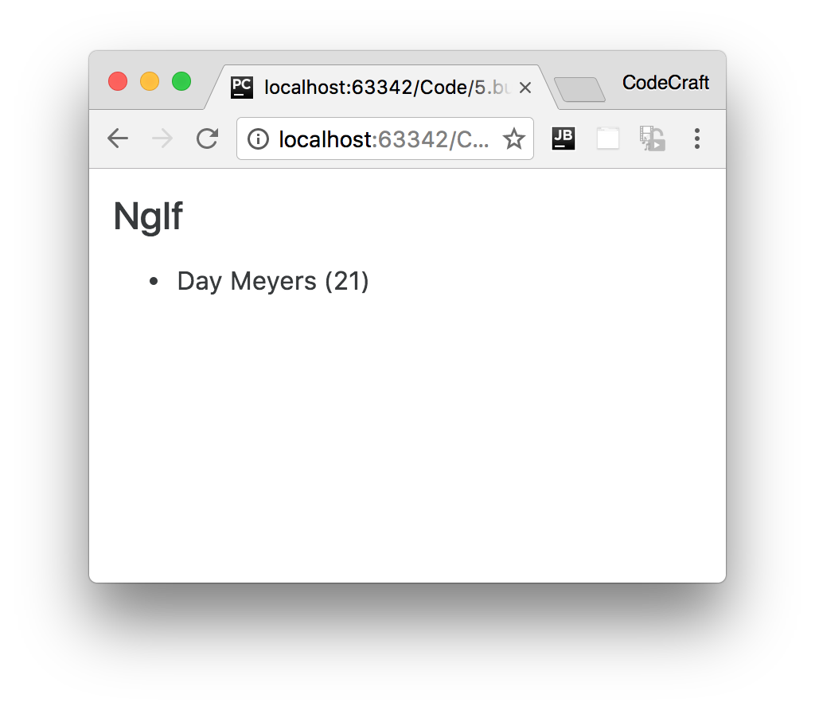



We

*can’t*

have two structural directives, directives starting with a *, attached to the

*same*

element.

The below code would

**not**

work:

<

ul *ngFor="let person of people" *ngIf="person.age < 30"

>

<li>{{ person.name }}</li>

>

<

/ul



This is exactly the same as Angular 1’s

ng-if

directive however Angular doesn’t

have a built-in alternative for

ng-show

. To achieve something similar you can bind

to the

[

hidden

]

property or use the

NgStyle

or

NgClass

directives we cover later in

this section.

**NgSwitch**

Lets imagine we wanted to print peoples names in different colours depending on *where* they are

from. Green for UK, Blue for USA, Red for HK.

With bootstrap we can change the text color by using the text-danger, text-success, text-warning and text-primary classes.

We *could* solve this by having a series of *ngIf statements, like so:

<ul *ngFor="let person of people">

<li *ngIf="person.country ==='UK'"

class="text-success">{{ person.name }} ({{ person.country }})

</li>

<li *ngIf="person.country === 'USA'"

class="text-primary">{{ person.name }} ({{ person.country }})

</li>

<li *ngIf="person.country === 'HK'"

class="text-danger">{{ person.name }} ({{ person.country }})

</li>

<li *ngIf="person.country !== 'HK' && person.country !== 'UK' && person.country !==

'USA'"

class="text-warning">{{ person.name }} ({{ person.country }})

</li>

</ul>

This initially seems to make sense until we try to create our *else* style element. We have to check to see if the person is not from any of the countries we have specified before. Resulting in a pretty long ngIf expression and it will only get worse the more countries we add.

Most languages, including javascript, have a language construct called a switch statement to solve this kind of problem. Angular also provides us with similar functionality via something called the NgSwitch directive.

This directive allows us to render different elements depending on a given condition, in fact the NgSwitch directive is actually a number of directives working in conjunction, like so:

*script.ts*

@Component({

selector: 'ngswitch-example',

template: `<h4>NgSwitch</h4>

<ul *ngFor="let person of people"

[ngSwitch]="person.country"> ①

<li *ngSwitchCase="'UK'" ②

class="text-success">{{ person.name }} ({{ person.country }})

</li>

<li *ngSwitchCase="'USA'"

class="text-primary">{{ person.name }} ({{ person.country }})

</li>

<li *ngSwitchCase="'HK'"

class="text-danger">{{ person.name }} ({{ person.country }})

</li>

<li *ngSwitchDefault

③

class="text-warning">{{ person.name }} ({{ person.country }})

</li>

<

/ul>`

})

class NgSwitchExampleComponent {

people: any[] = [

{

"name": "Douglas Pace",

"age": 35,

"country": 'MARS'

},

{

"name": "Mcleod Mueller",

"age": 32,

"country": 'USA'

},

{

"name": "Day Meyers",

"age": 21,

"country": 'HK'

},

{

"name": "Aguirre Ellis",

"age": 34,

"country": 'UK'

},

{

"name": "Cook Tyson",

"age": 32,

"country": 'USA'

}

];

}

1. We bind an expression to the ngSwitch directive.
2. The ngSwitchCase directive lets us define a condition which if it matches the expression in (1) will render the element it’s attached to.
3. If no conditions are met in the switch statement it will check to see if there is an ngSwitchDefault directive, if there is it will render the element thats attached to, however it is optional - if it’s not present it simply won’t display anything if no matching ngSwitchCase directive is found.

The key difference between the ngIf solution is that by using NgSwitch we evaluate the expression only once and then choose the element to display based on the result.

If we ran the above we would see:

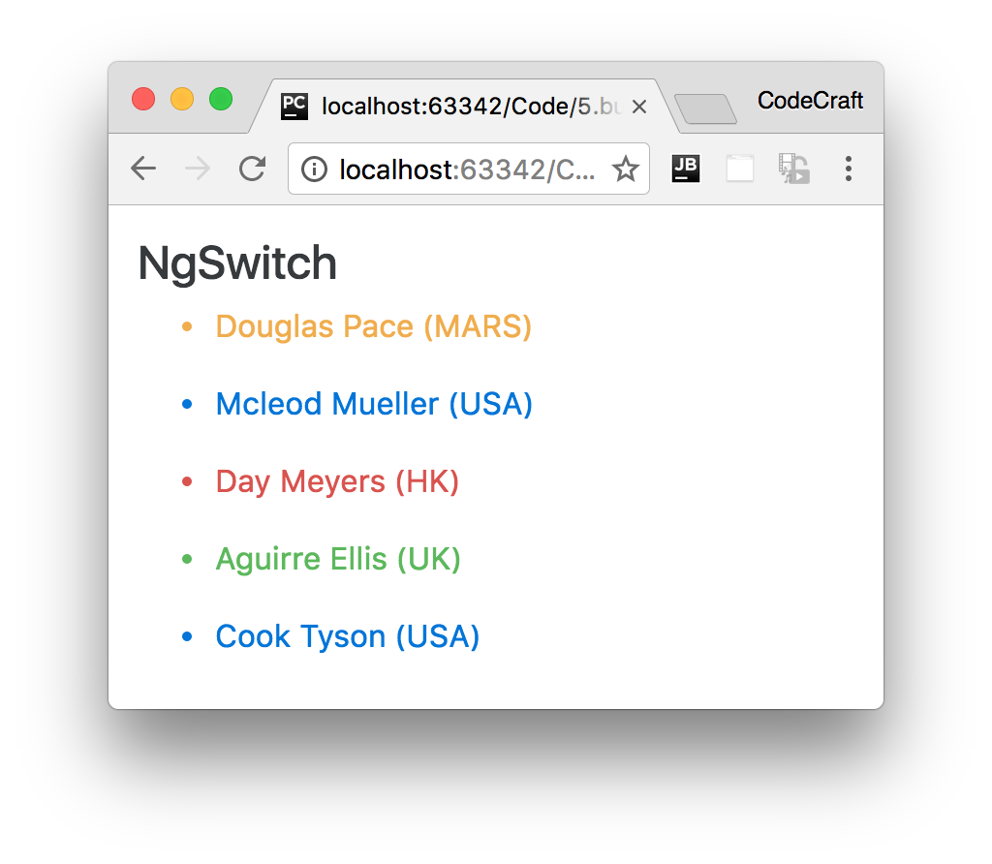



The use of

NgSwitch

here is just for example and isn’t an efficient way of solving

this problem. We would use either the

NgStyle

or

NgClass

directives which we’ll

cover in the next lecture.

**Summary**

With NgIf we can conditionally add or remove an element from the DOM.

If we are faced with multiple conditions a cleaner alternative to multiple nested NgIf statements is the NgSwitch series of directives.

**Listing**

<http://plnkr.co/edit/1mDlqE56ZxdiZbusUrva?p=preview>

*script.ts*

import {NgModule, Component} from '@angular/core'; import {BrowserModule} from '@angular/platform-browser';

import {platformBrowserDynamic} from '@angular/platform-browser-dynamic';

@Component({

selector: 'ngif-example',

template: `

<

h4>NgIf</h

4>

<

ul *ngFor="let person of people"

>

<li *ngIf="person.age < 30">

{{ person.name }} ({{ person.age }})

</li>

<

/ul

>

`

})

class NgIfExampleComponent {

people: any[] = [

{

"name": "Douglas Pace",

"age": 35

},

{

"name": "Mcleod Mueller",

"age": 32

},

{

"name": "Day Meyers",

"age": 21

},

{

"name": "Aguirre Ellis",

"age": 34

},

{

"name": "Cook Tyson",

"age": 32

}

];

}

@Component({

selector: 'ngswitch-example',

template: `<h4>NgSwitch</h4>

<

ul *ngFor="let person of people"

[ngSwitch]="person.country">

<li *ngSwitchCase="'UK'"

class="text-success">

{{ person.name }} ({{ person.country }})

</li>

<li *ngSwitchCase="'USA'"

class="text-primary">

{{ person.name }} ({{ person.country }})

</li>

<li *ngSwitchCase="'HK'"

class="text-danger">

{{ person.name }} ({{ person.country }})

</li>

<li *ngSwitchDefault

class="text-warning">

{{ person.name }} ({{ person.country }})

</li>

<

/ul>`

})

class NgSwitchExampleComponent {

people: any[] = [

{

"name": "Douglas Pace",

"age": 35,

"country": 'MARS'

},

{

"name": "Mcleod Mueller",

"age": 32,

"country": 'USA'

},

{

"name": "Day Meyers",

"age": 21,

"country": 'HK'

},

{

"name": "Aguirre Ellis",

"age": 34,

"country": 'UK'

},

{

"name": "Cook Tyson",

"age": 32,

"country": 'USA'

}

];

}

@Component({

selector: 'directives-app',

template: `

<ngswitch-example></ngswitch-example>

<ngif-example></ngif-example>

`

})

class DirectivesAppComponent {

}

@NgModule({

imports: [BrowserModule],

declarations: [

NgIfExampleComponent,

NgSwitchExampleComponent,

DirectivesAppComponent],

bootstrap: [DirectivesAppComponent]

})

class AppModule {

}

platformBrowserDynamic().bootstrapModule(AppModule);